**Creating a simple HTTP web server using a standalone installation of Node.js**  
**NOTE:** While this is a quick way to setup a lightweight web file server (that also supports HTTPS), the disk space used is around 60MB. Using the CW_Tools “run_jetty” command instead might be a quicker way to get a simple web file server: using “run_jetty” will make the files in the current directory available from http://localhost:8080/list/.  
  
  
Based on these links:  
<https://codyswartz.us/wp/finds/node-js-stand-alone-portable-with-npm>  
<https://gist.github.com/massahud/321a52f153e5d8f571be>  
  
  
o Download node.exe by getting it from the Windows 64-bit download here:  
<https://nodejs.org/en/download/>  
My node.exe (22MB) was extracted from node-v8.11.3-win-x64.zip.

o Download npm zip (11MB):  
<https://github.com/npm/npm/releases/tag/v6.1.0>

o Create a folder named: node_modules in the same folder as node.exe  
  
o Extract the NPM zip into the node_modules folder. This will create a sub-folder such as “node_modules/npm-6.1.0”.  
  
o Rename the “npm-6.1.0” sub-folder to just “npm”.  
  
o Copy npm.cmd out of the npm/bin/ folder into the root folder with node.exe  
  
o Open a command prompt in the node.exe directory.  
  
o Now you will be able to run your npm installers:  
npm install -g express

|  |
| --- |
| D:\tmp_nodejs>npm install -g express  + express@4.16.3  added 50 packages from 47 contributors in 3.266s |

npm install express –save

|  |
| --- |
| D:\tmp_nodejs>npm install express --save  + express@4.16.3  updated 1 package in 1.067s |

o Install simple web server (https://github.com/indexzero/http-server):

|  |
| --- |
| D:\tmp_nodejs>npm install http-server -g  D:\tmp_nodejs\http-server -> D:\tmp_nodejs\node_modules\http-server\bin\http-server  D:\tmp_nodejs\hs -> D:\tmp_nodejs\node_modules\http-server\bin\http-server  + http-server@0.11.1  added 25 packages from 28 contributors in 4.899s |

o Create a local “public” folder creating the file you want to server:  
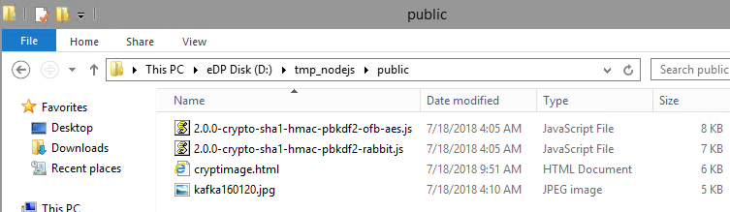  
  
o Launch the web server:

|  |
| --- |
| D:\tmp_nodejs>http-server -p 8888  Starting up http-server, serving ./public  Available on:  http://192.168.10.102:8888  http://127.0.0.1:8888  Hit CTRL-C to stop the server |

o Try and view the “cryptimage.html” file.   
It should load, including the image, and the JavaScript invoked by the “Encrypt” button should also work!:  
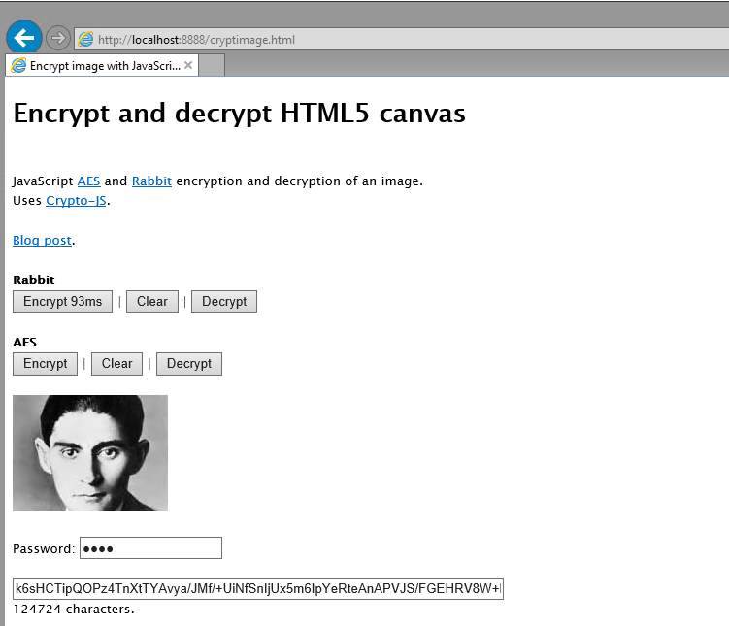  
  
FYI: Here’s what my Node.js directory now contains:  
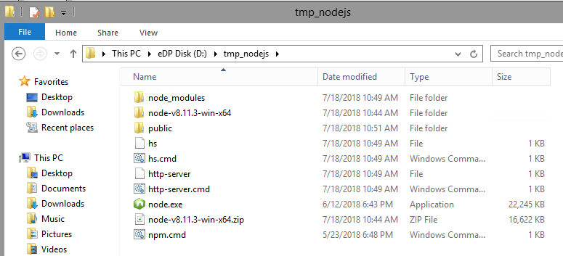  
  
*JeremyC 18-07-2018***END**